Quiz App Question Types

Ohm’s Law DC
CurrentSourceVoltmeterAndResistor | 0 | 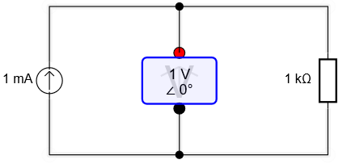
VoltageSourceAmmeterAndResistor | 1 | 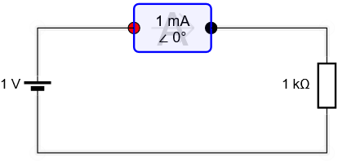
VoltageSourceCurrentSource  ResistorInParallel | 2 | 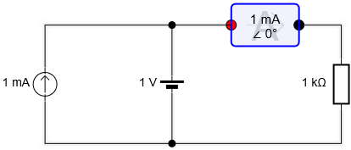
CurrentSourceVoltageSource  ResistorInSeries | 3 | 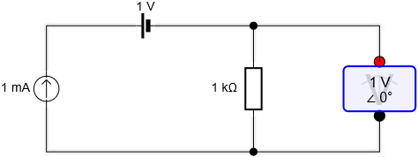
LevelFourCircuitA | 4 | 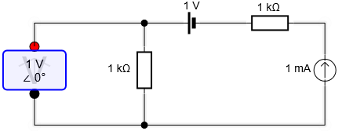
LevelFourCircuitB | 5 | 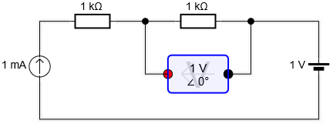
LevelFourCircuitC | 6 | 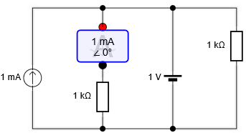

Kirchhoff’s Law DC
MakeLevelZeroVoltageCircuit | 0 | 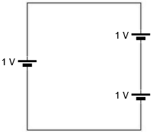
MakeLevelZeroCurrentCircuit | 1 | 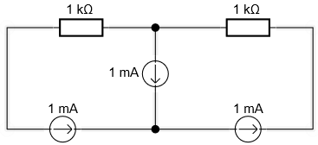
MakeLevelTwoVoltageCircuit | 2 | 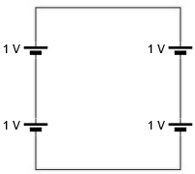
MakeLevelTwoCurrentCircuit | 3 | 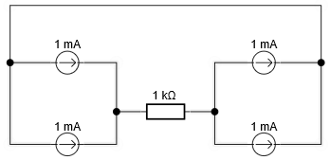
MakeLevelThreeCircuit | 4 | 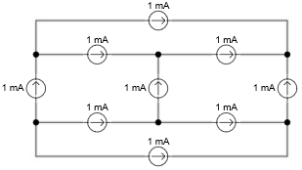
MakeLevelFourCircuit | 5 | 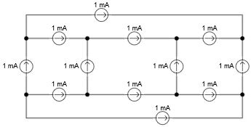

Resistor Networks
NetworksMakeTwoResistorsInParallel | 0 | 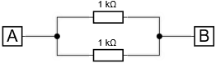
NetworksMakeTwoResistorsInSeries | 1 | 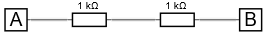
NetworksMakeThreeResistorsInSeries | 2
NetworksMakeThreeResistorsInParallel | 3 | 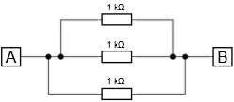
NetworksMakeOneInSeriesWithTwoInParallel | 4 | 0 |  | 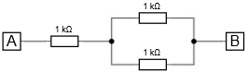
 |  | 1 |  | 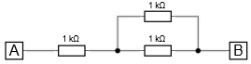
NetworksMakeOneInParallelWithASeriesPair | 5 | 0 |  | 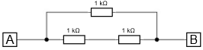
 |  | 1 |  | 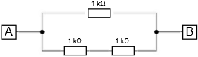
NetworksMakeFourInSeries | 6
NetworksMakeFourInParallel | 7 | 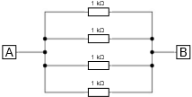
NetworksMakeOneInSeriesWithThreeInParallel | 8 | 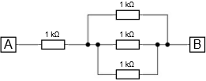
NetworksMakeTwoPairsInParallel | 9 | 0 | 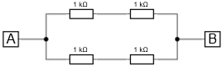
 |  | 1 | 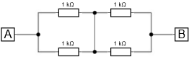
NetworksMakeOneInSeriesWithOneInParallelWithASeriesPair | 10 | 0 | 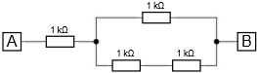
 |  | 1 | 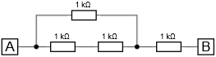
NetworksMakeTwoInSeriesThenTwoInParallel | 11 | 0 | 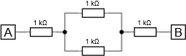
 |  | 1 | 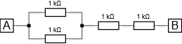
NetworksMakeOneInParallelWithThreeInSeries | 12 | 0 | 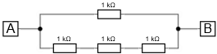
 |  | 1 | 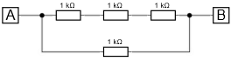
NetworksMakeOneInParallelWithOneInSeriesWithTwoInParallel | 13 | 0 | 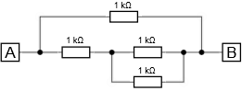
 |  | 1 | 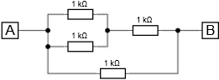
 |  | 2 | 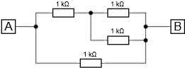
 |  | 3 | 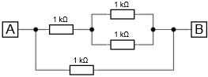
 |  | 4 | 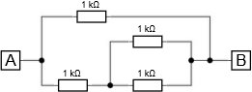
 |  | 5 | 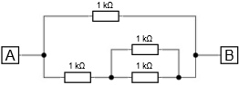
NetworksMakeFiveInDeltaYShape | 14 | 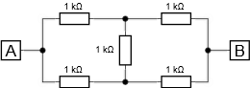

Dividers
DividersMakeBasicVoltageCircuitA | 0 | 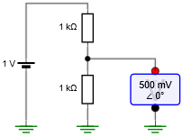
0: as shown
1: swap lower resistor with voltmeter
2: swap higher resistor with voltage source
3: do both swaps
DividersMakeBasicVoltageCircuitB | 1 | 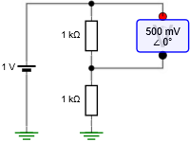
0: as shown
1: swap upper resistor with voltmeter
2: swap lower resistor with voltage source
3: do both swaps
DividersMakeBasicVoltageCircuitC | 2 | 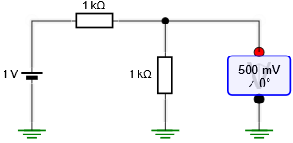
0: as shown
1: swap lower resistor with voltmeter
2: swap upper resistor with voltage source
3: do both swaps
DividersMakeBasicVoltageCircuitD | 3 | 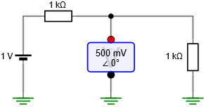
0: as shown;
1: swap voltage source and upper resistor
2: swap voltmeter with rightmost resistor
3: do both swaps
DividersMakeBasicCurrentCircuitE | 4 | 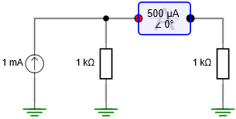
0: as shown
1: swap current source and left-most resistor
2: swap ammeter with right-most resistor
3: do both swaps
DividersMakeBasicCurrentCircuitF | 5 | 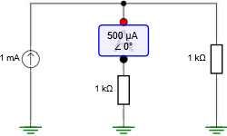
0: as shown
1: ammeter and series resistor swapped
DividersMakeBasicCurrentCircuitG | 6 | 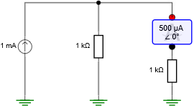
0: as shown
1: ammeter and series resistor swapped
DividersMakeDualVoltageCircuitA | 7 | 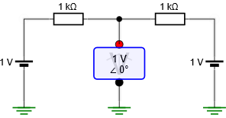
0: as shown
1: swap left-most voltage-source with resistor
2: swap right-most voltage-source with resistor
3: do both swaps
DividersMakeDualVoltageCircuitB | 8 | 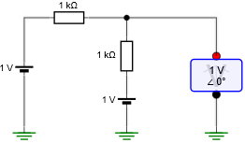
0: as shown
1: swap left-most voltage source and resistor
2: swap middle voltage source and resistor
3: do both swaps
DividersMakeDualCurrentCircuitD | 9 | 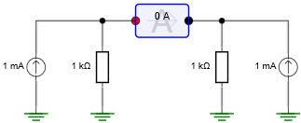
0: as shown
1: swap left-most current source and resistor
2: swap right-most current source and resistor
3: do both swaps
DividersMakeSingleVoltageDesignCircuitA | 10 | 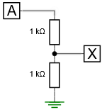
DividersMakeSingleVoltageDesignCircuitB | 11 | 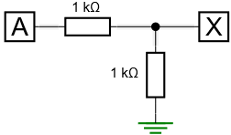
DividersMakeDualVoltageDesignCircuitA | 12 | 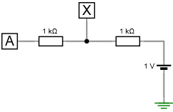
0: as shown
1: swap voltage source and right-most resistor
DividersMakeDualVoltageDesignCircuitB | 13 | 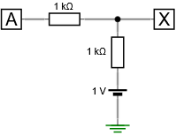
0: as shown
1: swap voltage source and vertical resistor

Circuit Theory
CircuitsMakeCircuitAv1 | 0 | 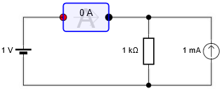
0: as shown
1: swap resistor and current source
2: swap voltage source and ammeter
3: do both swaps
CircuitsMakeCircuitAv2 | 1 | 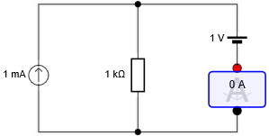
0: as shown
1: swap resistor and current source
2: swap voltage source and ammeter
3: do both swaps
CircuitsMakeCircuitBv1 | 2 | 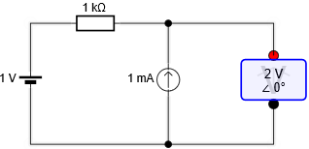
0: as shown
1: swap current source and voltmeter
2: swap voltage source and resistor
3 do both swaps
CircuitsMakeCircuitBv2 | 3 | 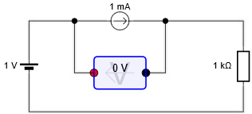
0: as shown
1: swap current source and voltmeter
2: swap voltage source and resistor
3 do both swaps
CircuitsMakeCircuitCv1 | 4 | 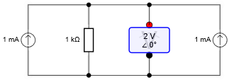
0: as shown
1: swap two random components
2: swap three random components
CircuitsMakeCircuitCv2 | 5 | 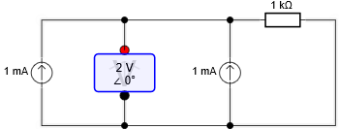
0: as shown
1: swap two random components
2: swap three random components
CircuitsMakeCircuitDv1 | 6 | 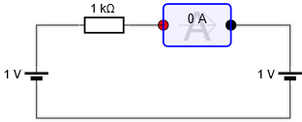
0: as shown
1: swap two random components
2: swap three random components
CircuitsMakeCircuitDv2 | 7 | 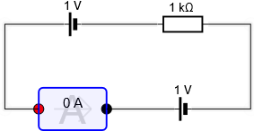
0: as shown
1: swap two random components
2: swap three random components
CircuitsMakeCircuitEv1 | 8 | 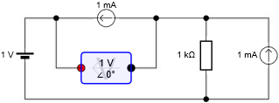
0: as shown
1: swap rightmost current source and resistor
2: swap upper current source and voltmeter
3 do both swaps
CircuitsMakeCircuitEv2 | 9 | 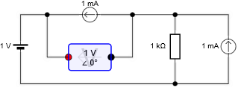
0: as shown
1: swap upper current source and resistor
2: swap rightmost current source and voltmeter
3 do both swaps
CircuitsMakeCircuitEv3 | 10 | 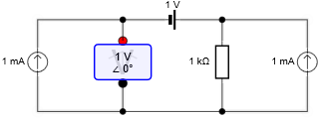
0: as shown
1: swap rightmost current source and resistor
2: swap leftmost current source and voltmeter
3 do both swaps
CircuitsMakeCircuitEv4 | 11 | 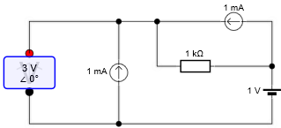
0: as shown
1: swap upper current source and resistor
2: swap leftmost current source and voltmeter
3 do both swaps
CircuitsMakeCircuitFv1 | 12 | 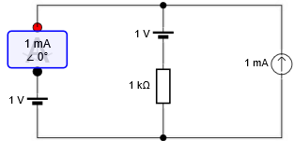
0: as shown
1: swap ammeter and left-most voltage source
2: swap middle voltage source and resistor
3 do both swaps
CircuitsMakeCircuitFv2 | 13 | 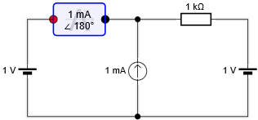
0: as shown
1: swap ammeter and left-most voltage source
2: swap rightmost voltage source and resistor
3 do both swaps

CircuitsMakeCircuitLevelFour | 14 | 