Touchdown on Titan

On the 14th of January 2005 the Huygens probe became the furthest man-made object ever to land on a celestial body. The probe had a seven year long journey to reach Titan the second largest moon in our solar system. The journey started with the launch on the 15th of October 1997. The Titan IV-B/Centaur was charged with job of blasting the Cassini spacecraft complete with the Huygens probe into space.
It is believed that Titans atmosphere resembles that of the earth some billion years ago, before life started pumping oxygen into the atmosphere. This forms one of the principle reasons for this mission, as scientists hope to gain a better understanding of our own planets history. The moon Titan is unique as it is the only moon in the known galaxy to support a planet like atmosphere.
This space exploration project faced many challenges and it required the contribution of 17 nations. One of the major problems facing the team was how they were going to get the 6000kg craft to Saturn. It was a journey 7 years in the making. There is no existing launch vehicle that could take the craft directly to Saturn. Thus, the mission designers had to rely on a technique known as “gravity assists”. The idea is to fly close to the inner planet’s to steal there planetary momentum to gain extra speed. Cassini-Huygens looped around the sun twice as shown in figure 1.
The two loops both allowed the craft to flyby Venus at the end of the second loop the craft flew by the earth and finally had enough momentum to reach the outer Solar system. Just one more flyby of Jupiter was required for the craft to reach its final destination. On reaching Saturn the Cassini obiter fired its rocket engine at just the right moment for it to become forever trapped in the giant planets orbit. From this position Cassini released Huygens to coast to Titan for 21 days. Where it encountered a parachute assisted landing.
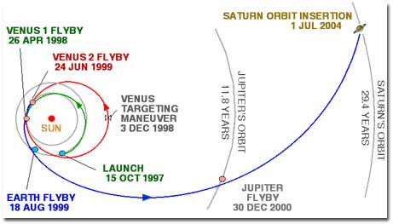
Figure1
Huygens shows Titan has similar geophysical properties to those on Earth, only with slight chemical differences. Instead of liquid water, Titan has liquid methane. Instead of silicate rocks, Titan has frozen water ice. Instead of dirt, Titan has hydrocarbon particles settling out of the atmosphere, and instead of lava, the volcanoes on Titan blast very cold ice into this bizarre atmosphere.
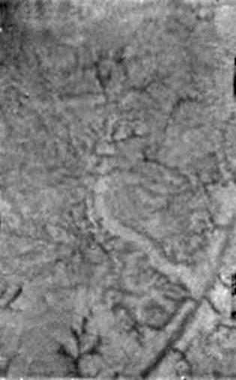
Figure 2
Figure 2 shows an image taken by Huygens showing water ice and methane springs on Titan.
Lead scientists claim that some of the organic compounds would be signs of life on our planet. However as Titan’s surface is a chilling -180°C it is very doubtful life would be able to survive a these temperatures, as all known forms of life require liquid water and Titan’s surface is to cold to comply with these demands.
With images coming back every day from Titan it is hard not to get too excited about what more wonders Huygens will be able to show us. In addition Cassini still has many more loops around Saturn to go before it becomes redundant, hopefully with the obiter and the Huygens probe together many of the mission aims may be met.

