The Cassini-Huygens Mission to Saturn and Titan
The Cassini-Huygens mission is a joint mission between NASA, the ESA, and the ASI, to discover more about the ringed-planet Saturn, and its mysterious, second largest moon Titan. The spacecraft has been named after two scientists who laid the foundations to finding more about the two planets in question, Christian Huygens and Jean-Dominique Cassini. Huygens was a Dutch scientist who, in1655, discovered Titan. Earlier on in his career he also discovered the famous rings of Saturn. Cassini, on the other hand, discovered that these rings had narrow separations between them, in 1675, known today as ‘Cassini’s division’.
Saturn and Titan have been the interest of scientists for many years now, in fact, the first space mission to fly past Saturn was in the late 1970’s, yet very little was known about this giant planet. Saturn has been observed from Earth since very early telescopes were invented. Observations of Saturn tell us that it is a large ‘ball’ of helium and hydrogen, flattened at its poles due to its rapid rotation. The two Voyager missions carried out by NASA in the 1980’s discovered new moons of Saturn, but they also made observations of Titan. The two missions observed that Titan had a mysterious orange atmosphere, with a high percentage of nitrogen and methane. This is unique in our solar system and it is believed that it may resemble that of a very young Earth. So the scene was set for a mission to discover more about both Saturn and Titan.
The Cassini-Huygens spacecraft is the largest interplanetary spacecraft ever built. It is made of two separate craft, ‘Cassini’ and ‘Huygens’. Cassini was designed to orbit Saturn, and Huygens to separate from Cassini and travel to the surface of the moon Titan and transmit its findings back to Cassini, which will then transmit both crafts findings back to Earth.
Cassini will orbit Saturn for four years, completing 75 orbits of the giant. Whilst orbiting Saturn it will also complete forty-four close fly-bys of Titan as well as numerous fly-bys of Saturn’s other moons. By doing that the Cassini module will make an extensive survey of Saturn and its moons, enabling scientists to hopefully answer the questions put forward in its mission objectives:
- What is the source of heat inside Saturn that produces 87 per cent more energy than the planet absorbs from sunlight?
- What is the origin of Saturn’s rings?
- Where do the subtle colours in the rings come from?
- Are there any more moons?
- Why has the moon Enceladus such an abnormally smooth surface? (Has recent melting erased craters?)
- What is the origin of the dark organic material covering one side of the moon Iapetus?
The Huygens craft was designed to ‘break off’ from Cassini and land on Titan. It is the first craft to land on a world outside the ‘terrestrial planets’ of our solar system. Huygens took pictures of Titan and as it was descending and once it had landed. These images were then sent back to Cassini and stored four times on solid state recorders (used in favour of the usual tape recorders), which then transmitted them back to Earth. Huygens also carried instruments to test the surface of Titan and its atmosphere. The findings on Titan are hoped to answer the following questions:
- Which chemical reactions are occurring in Titan’s atmosphere?
- What is the source of methane, a compound associated to biological activity on Earth, which is so abundant in Titan’s atmosphere?
- Are there any oceans on Titan?
- Do more complex organic compounds and ‘pre-biotic’ molecules exist on Titan?
It is also believed that the findings may offer clues as to how life began on Earth.
Many technological challenges had to be overcome in order for the mission to be a success. First of all, at 5.6 tonnes, the spacecraft was far too heavy to be just blasted towards Saturn and make it. Therefore, the craft made four fly-bys in all – 2 two of Venus (April 1998, and June 1999), one of Earth (August 1999), and one of Jupiter (December 2000). The assistance of gravity in these cases was the equivalent to an extra 68040kg of rocket fuel. Secondly, the Huygens shield had to be built to withstand the 18000K it would experience on entry to Titan. Lastly, scientists were unsure about what kind of surface Huygens was going to encounter when it landed, therefore had to be fitted with equipment for every eventuality.
So, on the 15th October 1997 the Cassini-Huygens spacecraft was launched for Cape Canaveral in the USA. In December 2004, towards the end of Cassini's third orbit around Saturn, the Huygens probe was ejected on a 22-day cruise to Titan. Huygens reached Titan on 14 January 2005.
On descent the camera aboard Huygens took several pictures and transmitted them back to Cassini, which then turned to face Earth and transmitted them back. The first clear picture, taken from 16km above the moons surface showed drainage channels on the surface of Titan, which seemed to lead to a shoreline (similar to those seen on Earth). This could be due to water, though it’s probable that another kind of liquid made the channel. Also, it appears the surface of Titan is made up of rocks, ice, and dust.
Huygens collected images and data for about 150 minutes. These raw images and data are now being closely studied by scientists across the world and new discoveries are sure to be made about this mysterious moon. as well as the four years worth of data that will be gained from Cassini until 2008/9. Below is the first image of Titan talked about above, along with the first colour image to be released. At the bottom is a model picture of the Cassini-Huygens spacecraft.
Chris Tattersall, York.
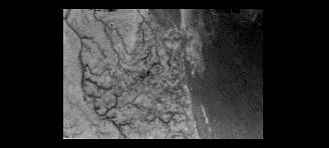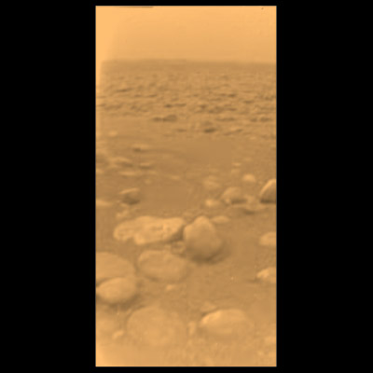

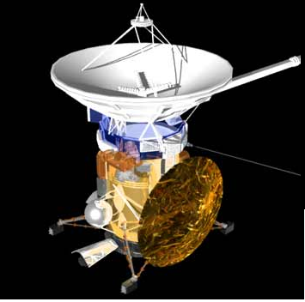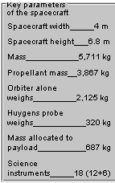

To complete this article I used to the website http://www.esa.int/export/SPECIALS/Cassini-Huygens/index.html for images and information on the mission.

