Cassini Huygens – Mission to Titan!

How does going back in time 3.8 billion years ago and looking at a primitive Earth long before life as we know it evolved? Far fetched? That’s what scientists have just done!
Well, actually that’s not quite true, but almost as incredibly, a space probe has successfully landed on an alien planet around 9 times further away from the Sun than the Earth. That’s almost a whopping billion miles from Earth!
This probe, named Huygens after the Dutch astronomer Christiaan Huygens who discovered Saturn’s largest moon Titan in 1655, has sent back the first information and photographs from the surface of the named moon. That is the furthest that a space probe has ever landed from the Earth. This major feat was achieved by scientists from around the globe, encompassing the European space agency, NASA, and the Italian space agency, Agenzia Spaziale.
Titan is rare in our solar system, that is – it is the only moon with an atmosphere surrounding it. This makes it very interesting especially as living organisms most likely cannot develop without an atmosphere. There may not be much hope of finding life forms on the surface but before scientists could decide they needed to know exactly what the surface was like. Titan's atmosphere might consist of compounds similar to those present in the “primordial days of the Earth's”.
Huygens journey to Titan, a 7 year piggyback ride on the Cassini probe was fraught with peril and covered billions of miles due to the ingenious method used to propel the probe. Current solutions do not have enough fuel to directly propel a rocket to Saturn, so a technique
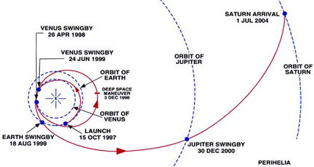
called “Gravitationally assisted manoeuvres” is used where the duo swung around planets to gain velocity as illustrated in the diagram (bottom left) with the Sun being the blue cross in the centre.

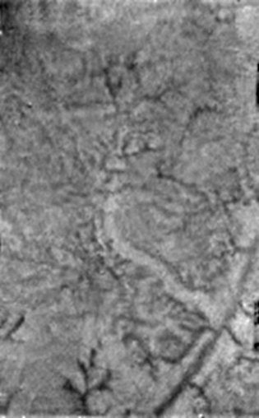
Left: A shot taken by Huygens in its decent through Titans thick atmosphere composed of Nitrogen among other gasses. “Channels” can clearly be seen, probably formed by running liquid hydrocarbons rather than water.

Some of the more exciting news and pictures released about the mission show “uplands” and “oceans”. These oceans are separated from the dry land by features very similar to those on Earth, with coastal regions featuring islands and coves etc. The lakes and rivers appear dry at the moment although it is realistic that they were flowing in the not too distant past.
It is worth noting that Titan is never likely to be a popular holiday destination as the pressure at the surface is about the same as scuba diving at twenty feet and the liquid is likely to be similar to petrol. Methane springs have also been discovered as well as the fact that it may rain! Again, as I cannot stress enough, you wouldn’t want to paddle in this rain especially as surface temperatures are as low at minus 178 degrees centigrade – seriously cold!
The mission has been a great success due to hard work, teamwork and a pinch of luck!
Sources
Images and information courtesy of the following websites and Dr D Jenkins of the University of York.

http://space.about.com/
http://www.esa.int/SPECIALS/Cassini-Huygens
http://www.nasa.gov/mission_pages/cassini/

